

**LAB I - CAUSAL FORESTS**



In April 2016, Airbnb launched its complaint line.[1] We are interested in exploring the causal effect of the new complaint line on the ratings on Airbnbs and nightly prices of Airbnbs (outcome variables). You will develop causal forest models to estimate the causal impact of Airbnb’s new feature / policy change. To start with, you need to code your data. You need a binary variable: *Code all observations after April, 2016 as 1 and 0 otherwise.* Call the new variable “treatment.” You can access the in-class lab on Posit Cloud for an example. **I have uploaded the Airbnb data to the lab** we walked through in class for your convenience.

Please do not blindly copy and paste the code. Check out [the documentation](https://grf-labs.github.io/grf/reference/causal_forest.html) for any additional arguments you can use, any helper functions, additional outputs from the model etc. There are also really nice, extensive [tutorials](https://grf-labs.github.io/grf/articles/grf_guide.html) on how to visualize your causal forest models etc. Please be curious and explore. This is an open ended assignment and you are the learner. In the end, we will all have different ways of approaching the problem. This is great because we will learn from each other. Your submission will be shared with the rest of the class members for this purpose.

### Questions:

1. Build causal forests. In a table, list the variables you use in the models and explain briefly why you decided to include them (why could it be important w.r.t. treatment-outcome?).
2. What is the causal impact of Airbnb’s new complaint line on the ratings?
3. What is the causal impact of Airbnb’s new complaint line on the nightly prices?
4. For both Question 2 and 3, please estimate the following effects and the standard error of the mean for each estimate:[2]
   1. The Individual Treatment Effect (ITE)
   2. The Conditional Average Treatment Effect (CATE)
   3. The Conditional Average Treatment Effect on Treated (CATET)
   4. CATE and CATET for New York City, NY
   5. CATE and CATET for Austin, TX
5. In a few paragraphs, describe your thought process in developing the causal forest models, explain, interpret, and discuss your results. What would be your main point if you were to report your results to the Airbnb team? In addition, use bullet points at the end of your write-up to list your key takeaways and lessons learned from the analysis.

### Deliverables:

You will submit **two separate PDF documents on Canvas**:

1. The first PDF will include your answers to the lab questions. You may want to create your own copy of the Google Doc, or download it as a MS Word document. Do whichever you like. When you are done answering the questions, please save it using the following naming convention: **LastName-FirstName-Answers.PDF** *-This is the main submission file*
2. The second PDF will be the code file you will generate in Posit Cloud as a PDF file when you are done working on the code. Please see the guidelines starting from the next page. Name it as as **LastName-FirstName-Code.PDF** *-This is the supplemental file*

**How to complete labs in five steps**

**Step 0:**

First, read [**How to use Posit Cloud**](https://docs.google.com/document/d/1CcAbFVQYwOJb5AiYusQ68_BX1WIPnz6-7N1_dWYs44M/edit?usp=sharing) in its entirety.

**Step 1:** In Posit Cloud, either start with the lab (where 10k Airbnb data is uploaded) or use your project. Start with clicking the ‘Start’ button to make your own derived copy (or to continue your work on your copy by clicking the ‘Continue’ Button). The assignment will open in an IDE.

Start working on a lab:

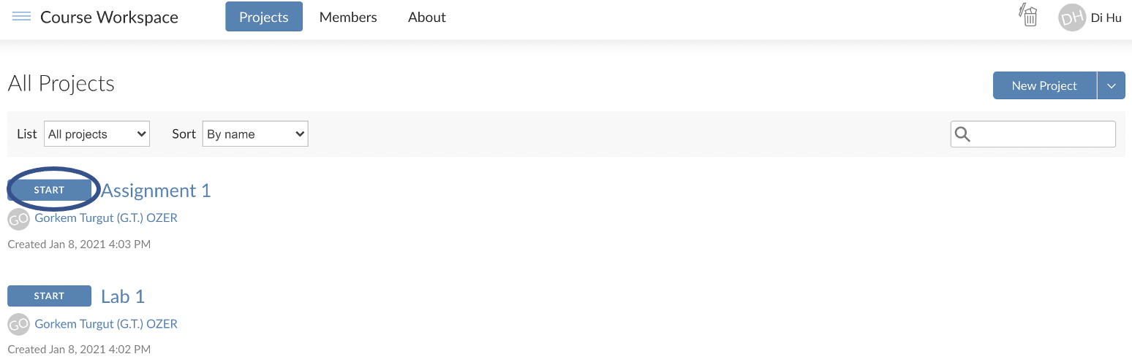

If you already started once, continue working on a lab:

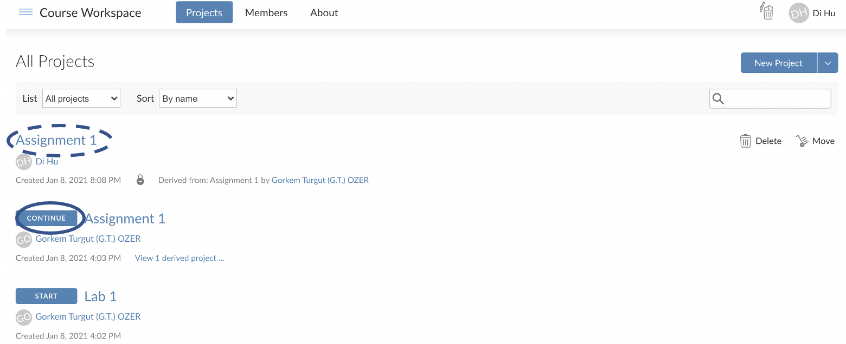

**Step 2:** When the lab opens, look to the right bottom of the window, and you will see several files and folders there. The name of the file will correspond to the name of the lab.

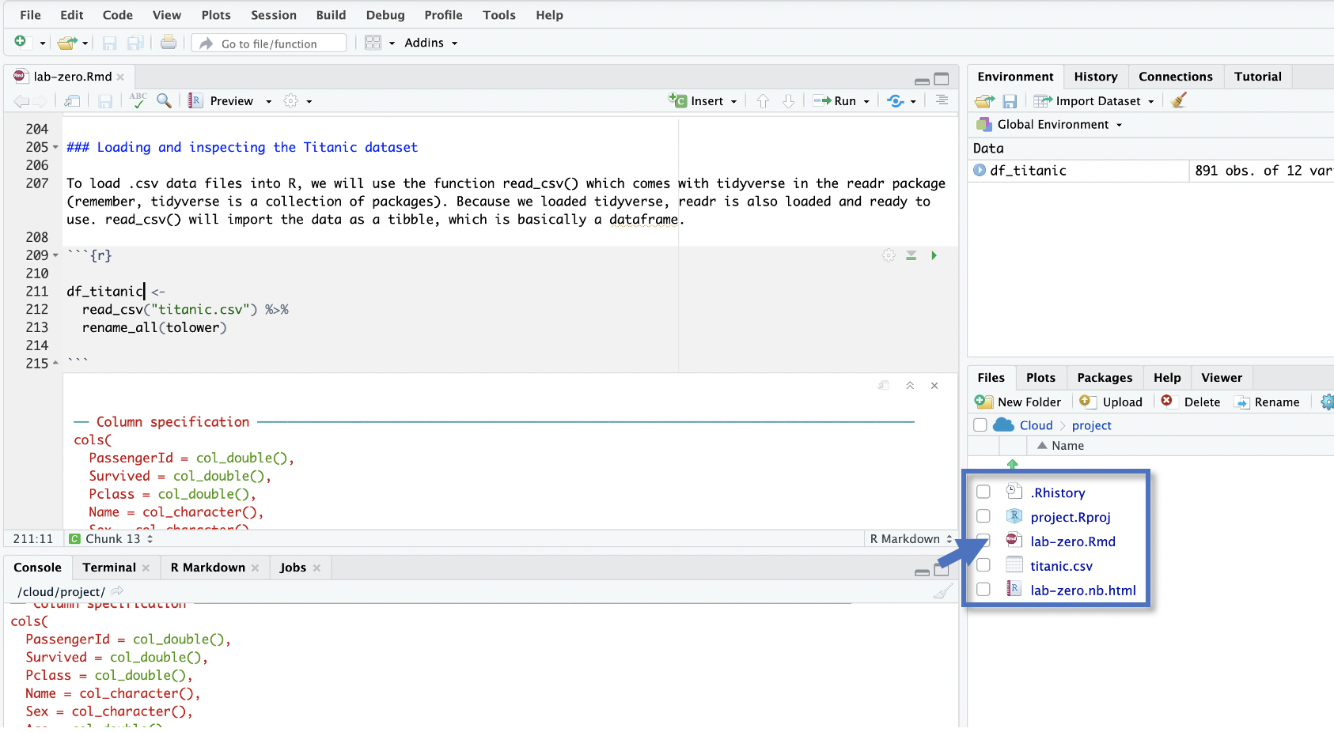

**Step 3:** As you know, you’ll enter your R commands between special markers called “[chunks](https://rmarkdown.rstudio.com/lesson-3.html).” Labs may come with some comments and an empty chunk to start with. A good practice is to use a different chunk for each question (or subquestion in a long question).

```{r}

*Your R commands here*

```

**Step 4:** When you are done answering the questions, style your code using **StyleR**. Install styler and style your code file following the example [here](https://www.tidyverse.org/blog/2017/12/styler-1.0.0/).

**Step 5:** After you fix any styling issues you may have, follow the instructions on the next page to create a **PDF** of your R Notebook with the naming convention **LastName-FirstName-Code.PDF**

**Step X:** Submit the two PDFs you now have through Canvas under the respective assignment:

1. LastName_FirstName-**Answers**.PDF (will include your answers to the questions)
2. LastName_FirstName-**Code**.PDF (will include your report including your code)

**How to create a PDF of your code in an R Notebook**

~~0. First, run the following two lines of code in your R Console to install the necessary components:~~

~~tinytex::install_tinytex() => This should not be needed. Try it if you have trouble.~~

1. To create a PDF (or Word) version of your work from an R Notebook, you need to have the following lines of code at the top of your R notebook. You can copy and paste from below and change the title. When you are using a provided lab/assignment template, these lines should already be in the file.

---

title: "Your Title"

output:

html_notebook: default

pdf_document:

latex_engine: xelatex

always_allow_html: yes

---

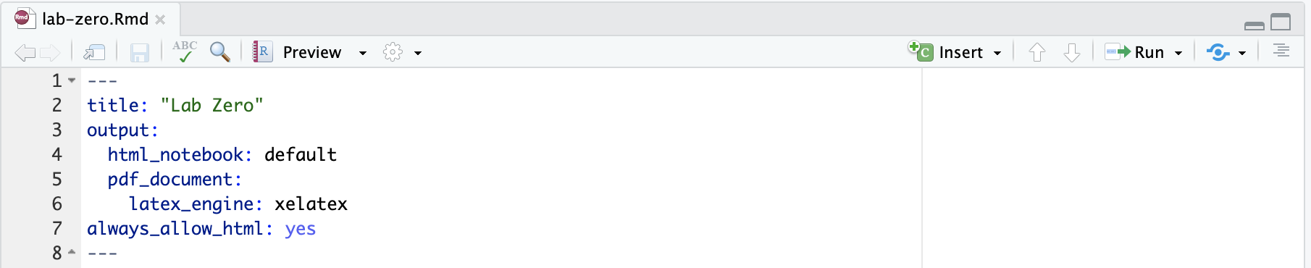

2. Save your file after adding these lines. Then, click the down arrow next to the “Preview.” This will show the options as shown below. Choose the PDF (or PDF) option to create a report of your work in seconds:

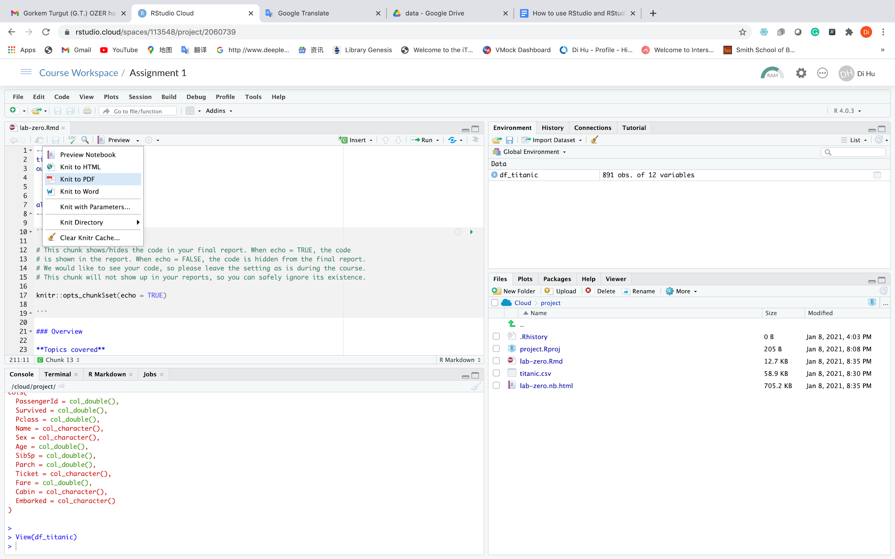

3. Here you go:

- If you choose the PDF option, your PDF report will open in a new window automatically for you to save.

- If you choose the Word option (not needed for the course), you will see a prompt to download the file.

1. <https://www.vox.com/2016/5/31/11821396/airbnbs-neighbors-tool-complaint-rental>
2. Note that this is the *standard error of the mean*. In the code we walked through in class, we calculated the *standard error of the estimate*.